

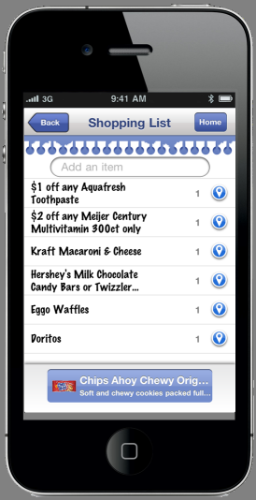

For

Professor Charles Kaplan

Systems Analysis & Design – Capstone Project

Farmingdale State College

Farmingdale, NY

By

Jay R. Kaplan

BCS 301

Table of Contents

Three Real World Problems 3

Problem Statement 4

Business Case 5

Gantt Chart 7

System Requirements 8

Context-Level Diagram 10

Diagram 0 11

Entity Relationship Diagram 12

Testing Design 13

# Three Real World Problems

1. ABA sports is a local provider of sports leagues for adults. The company started by offering solely softball leagues but has grown to offer basketball, flag football, and dodgeball. ABA has a problem tracking all of its current and potential players. It has contact, mainly with team managers and without real contact with players. The league wants to be able to market to everybody that plays within its leagues and offer additional players to teams through a free agent search. ABA wants to create a mobile app where all players are required to sign up, giving ABA not only a tremendous database of Long Island’s active sports players, but the ability to offer teams the opportunity to reach out to other players (“free agents”) through the use of a location-based sports app.
2. Georgio’s Coffee Roasters is a small, independent coffee shop located on New Highway in Farmingdale. It’s been in business for 15 years and has slowly grown through word of mouth and many positive online reviews. The coffee business is a tough one in which to compete, given that both Starbucks and Dunkin Donuts are available within any 10 minute direction on Long Island. The business is looking to grow, not by cups of coffee sold per person per day, but by the high margin products that the store does sell, which are their bags of beans. Their coffee beans are imported from farms in Columbia and then roasted on Long Island in a 100-year-old coffee bean roaster. It is this process that has made Georgio’s a success with their customers. The problem that the business faces is how to sell more of their high margin items to both their current customers as well as the daily traffic that comes through its doors. The business wants to do this by offering a mobile store app to its customers that can offer specials when they pass by the store, as well as remind them to check out Georgio’s coffee when they are near another coffee location using geo location tracking within the software.
3. King Kullen is a Long Island supermarket chain that touts itself as one of the first supermarkets on Long Island. King Kullen has closed many stores over the years due to new competitors entering the market. Fairway, Trader Joe’s, Whole Foods and smaller specialty stores have eaten away at King Kullen’s share of the market. King Kullen needs to find a way to keep its current customers from leaving and compete with other super markets who are offering mobile apps and incentives to its customer base.

# Problem Statement

King Kullen does not have a mobile app that can compete with other Long Island grocery store competitors.

King Kullen needs a mobile shopping app to not only compete in the Long Island market, but also enhance shopper’s experiences. The app will offer interactive shopping lists, mobile coupons, and an in-store product locator. The shopping list app will allow you to enter items into your phone. As the shopper “walks” you around the store, it will find the items for you, as well as suggest similar items that are on sale. Customers will be able to save previously purchased items and get text alerts about in-store sales. The app will also provide in-store product look ups and guide shoppers through the store.

Customers are more likely to shop at a store that has an app. Interactive retail store apps have shown to increase brand loyalty and the average amount of a checkout order. The King Kullen shopping app needs to have an easy, usable interface and store-finder feature.

# Business Case

**Project Description:**

Create an enhanced shopping experience for King Kullen customers. The app will feature interactive shopping lists, mobile coupons, and in-store product finder. Customers will input products into the app at home. When they enter the store, the app turns the store into an interactive shopping experience. It can help customers locate items from their shopping list as well as offer sales and coupons directly on the phone. Customers on the go will be able to look up-as well as find- products both on the app and in the store without trying to find a store employee.

**Project Benefits:**

Mobile applications in the retail space have shown a number of benefits to companies. Retailers can expect to see an increase in brand and store loyalty as mobile app users are more likely to shop in a store to which they feel connected, thereby making it easier for shoppers to find their items and check out of the store. This will contribute to King Kullen’s competitive advantage in the Long Island market. The repeated use of the app, along with the mobile coupons, will increase store traffic and average checkout dollars per user. Kroger and Safeway reported an increase of 1% when shoppers used the mobile shopping apps in their stores. We will use this figure when calculating our sales increase figures.

**Project Scope:**

Based on a reasonable assumption from a mobile app development company in the United States called Otreva, the cost of the app will be $200,000 and take about 2600 hours for development at a rate of $75 per hour. These estimates were based on the calculations from the Otreva website for the type of mobile app that King Kullen is looking for.

**Projected Financial Results:**

Estimated Increase from Mobile App Usage = $517M (Gross Sales 2013) X 1% = 5 Million dollars in sales from mobile app usage.

$200,000 (Project Cost)

With a 1% increase in gross sales, the payback period is within the first month.

**Project Risks:**

The risks for this type of project are low adaptation of the mobile app by our customers. Will the King Kullen customer be willing to use the app repeatedly in-store? The app could have problems tracking items or offering mobile coupons, whether it is that the data that is used for the app is not correct, or the products the customer is looking for is not stocked in that local King Kullen. If these problems happened after our initial launch, customers would be unwilling to want to use it often.

**Alternatives:**

The alternative for King Kullen could be an in store kiosk, where the customer could use an online web app on the King Kullen site, select their shopping list on the web, and then print the shopping list in the store. The printed list would tell them which aisles items are in, which items are on sale or have coupons, and offer suggestions for similar items.

**Project Review:**

The success of the project will be based on the volume of King Kullen customers who use the app on a repeated basis. The revenues of mobile app users will be tracked and compared with non-app users. The frequency of app users will be tracked versus non-app users to determine if app users are more likely to purchase certain products. King Kullen will also look for customer feedback through surveys and focus groups.

# Gantt Chart

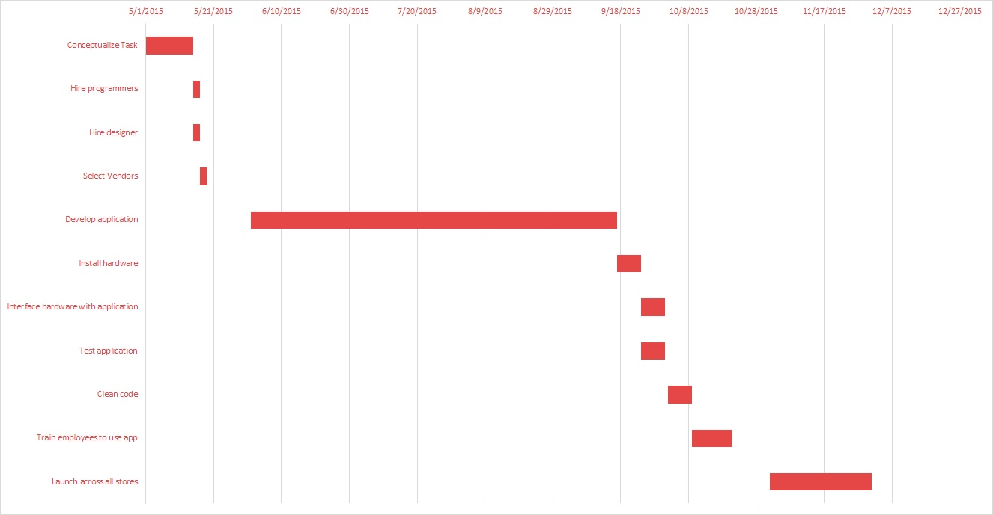

# System Requirements

**Outputs:**

* The mobile coupon database must update regularly (at least twice a day) in order to provide up-to-date coupons for customers
* The product database must update with each transaction completed in order to keep an accurate record of inventory
* User shopping list database will be able to save and pull up existing shopping lists specific to each customer
* The King Kullen shopper database will keep an updated record of users and will query the shopping list mobile app whenever a user signs in
* The user database will verify whether or not a user is registered
* User database will send all first time users a feedback survey with some sort of incentive. After every 10 times the shopper uses the app in-store, they will receive a new survey

**Inputs:**

* Shoppers will search for product information on their mobile devices
* Shoppers will enter their username and password in order to access their profile
* Shoppers will create individual shopping lists with updated product information and coupons
* Shoppers will search for relevant coupons for specific products

**Processes:**

* Databases will update regularly in order to provide the best customer experience
* As shoppers add items to their shopping lists, the product database will provide up-to-date product information and the coupon database will provide coupons (if applicable) for all items
* User database processes shopper login information to determine registration status
* Product database processes data with each transaction to provide inventory status

**Performance:**

* The system must be able to support at least 100 users per store
* System will be operational 24/7, 365 days a year
* Response time for customer searches and queries should be no longer than four seconds

**Controls:**

* The system will provide login security for shoppers to prevent identification theft
* Customer profiles and shopping lists can only be altered by customers or authorized users in store
* The coupon database will prevent customers from using more than two coupons per item

# Context-Level Diagram

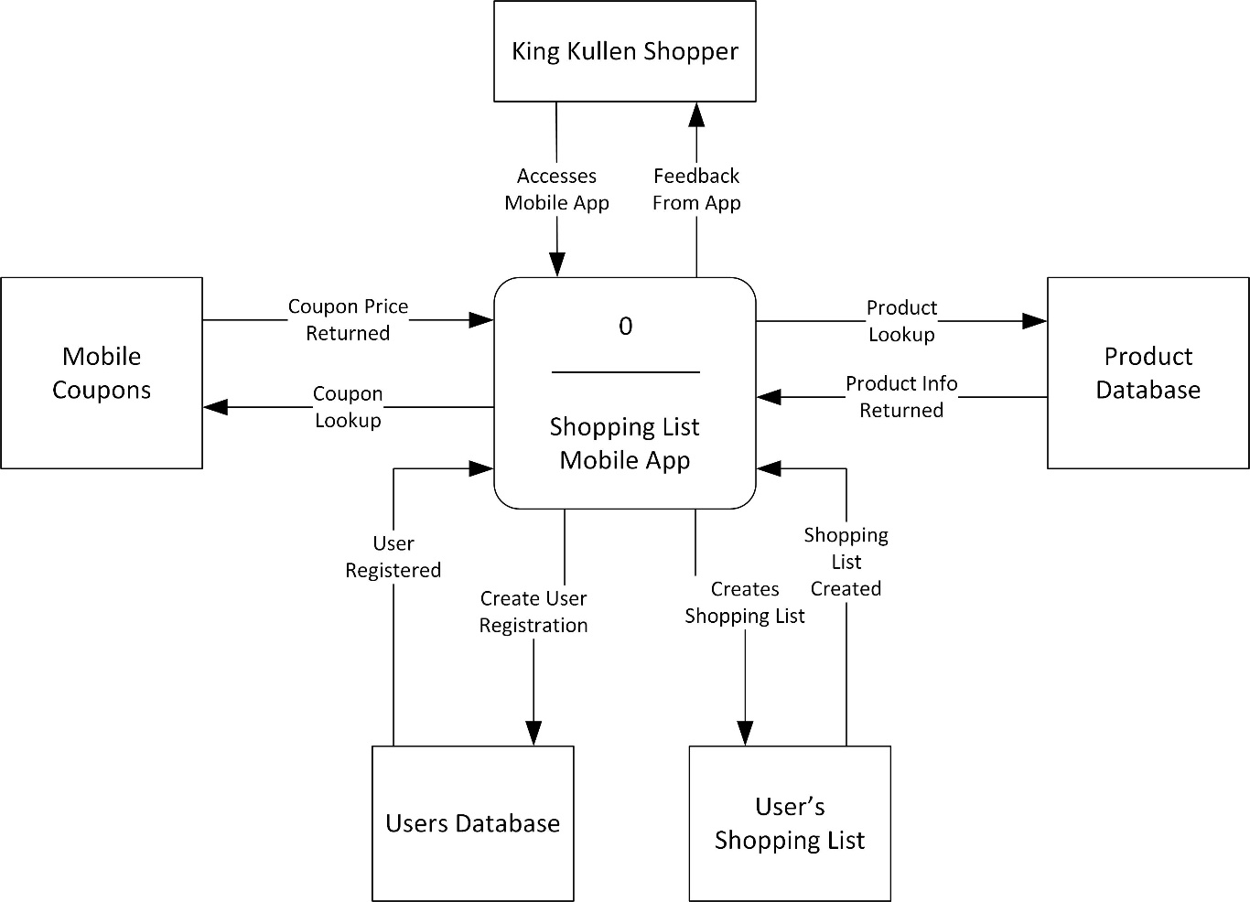

# Diagram 0

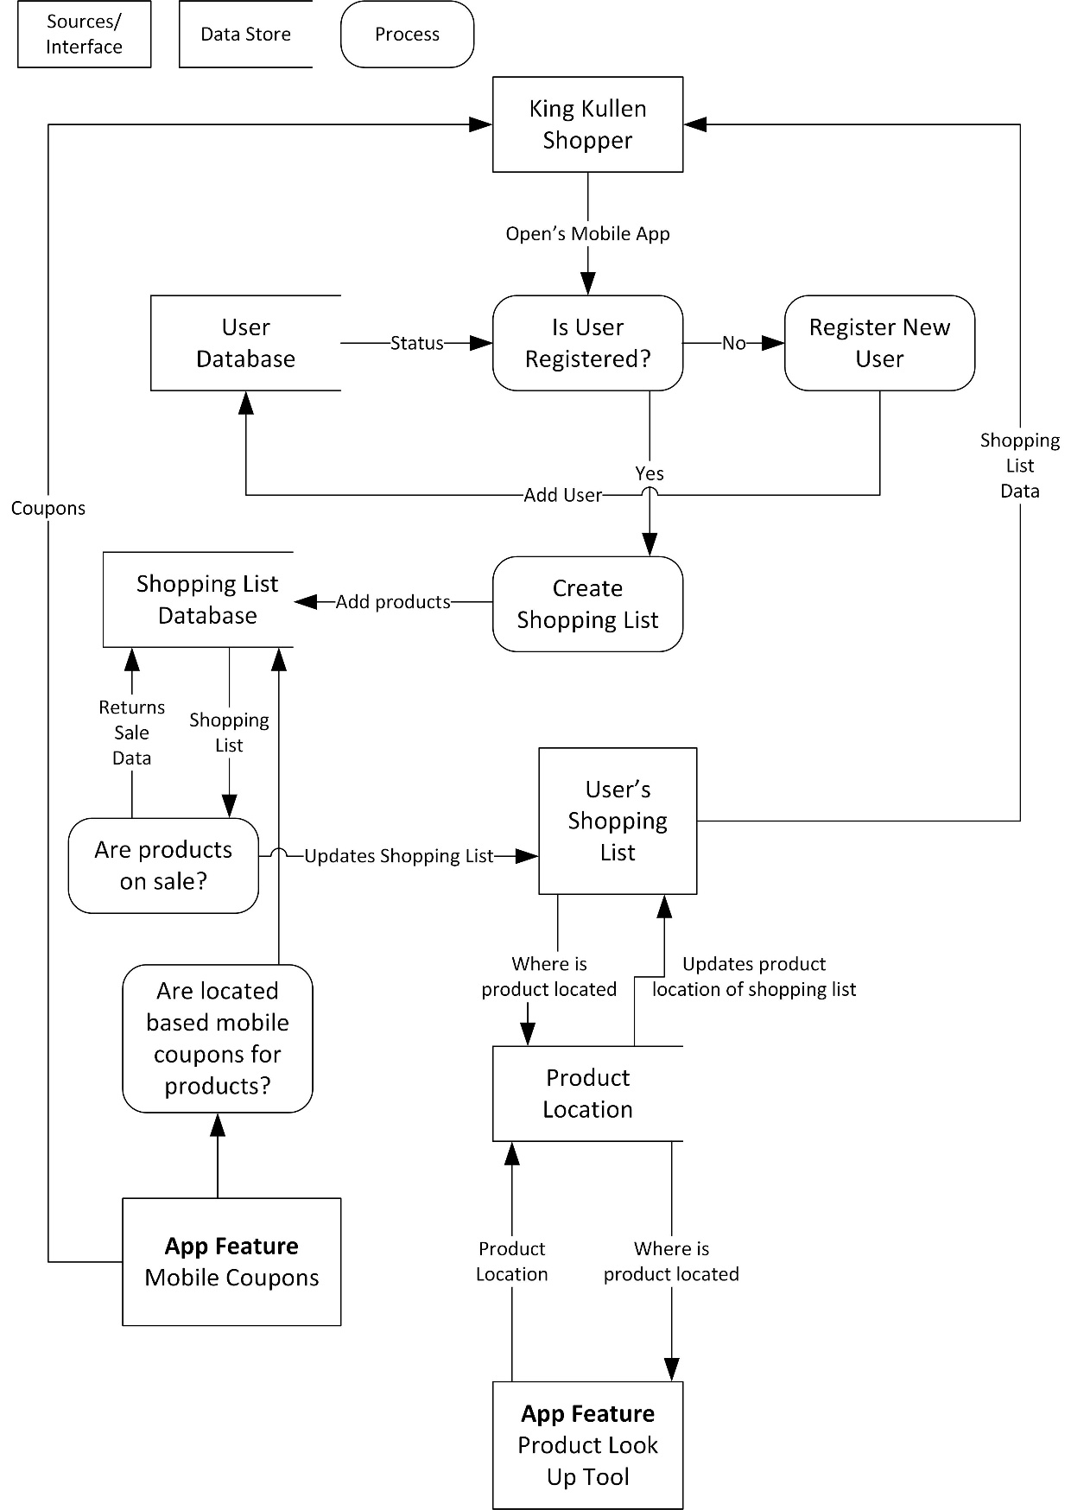

# Entity Relationship Diagram



# Testing Design

**Type of testing and justification**

The testing design that makes the most sense for our mobile app would consist of a number of detailed procedures that describes the different testing scenarios that King Kullen shoppers would experience. The design would be a combination of three phases of testing that would include unit, integration, and systems testing. The first step would test the data entry points, such as user registration, adding products to shopping lists, and adding products to the database. The next steps would be to test the processing points and see how the data points interact and flow back and forth to each entity. This testing would also involve multiple queries to the database interacting with adding products, mobile shopping coupons, and adding and deleting products from user shopping lists. A final systems test would be put into place that would test all points of the system as a whole and produce reports and test that all systems, entries, queries, and reports are generating correctly.

**What is to be tested and why**

1. User registration – can users register within the system?
2. Shopping list creation – can a shopping list be created?
3. Add products to shopping list – can products be added to the shopping list?
4. Promotions – are products on sale and is the data getting sent back to the app and the users’ shopping lists?
5. Mobile Coupons – are mobile coupons registering in store?
6. Product data – are products loading into the database?
7. Product location – are products registering in their correct locations?
8. Product look up tool – are products getting looked up in store based on users shopping list?

**Testing activities**

1. Testing for user registration:
   1. Is the database registering the user
   2. Are new users getting added to the database
   3. Are current users registering twice
   4. Can a user change or delete their registration
   5. Is all the user information getting added to the right locations
2. Testing for create shopping lists:
   1. Does the shopping list create
   2. Can you add items to the shopping list
   3. Are you able to delete or modify items from the list
   4. Does the list save to the user
3. Testing for Product Lookup
   1. Are product look-up queries being sent to the database
   2. Is the database returning any information back to the user
   3. Is the database returning correct information back to the user
4. Testing for Shopping List Database
   1. Are user shopping lists getting stored
   2. Are user shopping lists able to be retrieved
   3. Are past purchases tracking
   4. Are any products on sale
   5. Is sale data getting sent to the shopping list
5. Testing for Mobile Coupons
   1. Are any products on sale
   2. Are any products with coupons triggering mobile coupons
   3. Are these mobile coupons sent back to the users’ shopping lists
   4. Is this information getting sent back to the shopping in-store
   5. Are any products from past shopping lists on sale

**Data collection instrument**

The data collection instrument would be an evaluation form given to King Kullen’s internal group of shopping app testers. All questions would be in a combination numerical rating scale with numbers from 1 through 6, and a side scale letting the evaluator know that a score between one and two is unsatisfactory, between three and four is acceptable, and six would be excellent. The form would evaluate the following information:

* **Shopping List Output:**
* Accuracy of products, location, and price
* Ease of creating, adding, and deleting shopping lists and products
* Timeliness of information
* **User Interface:**
* Ease of use
* Ease of navigation
* Appropriate options available
* Clarity of how to operate app
* **App Stability:**
* Reliability of app on their devices
* Speed and performance of operations
* **Overall Experience:**
* Rate your overall experience